Protection of the Atmosphere

Purchase the original impressionistic (hand-drawn) charts here

Chart numbering: The charts are originally numbered as they were in my training, and I’ve also added the corresponding numbering for the “Montessori For Everyone” charts (MFE) when available.

Pre-requisite: The Sun and the Earth

MATERIALS:
- Charts 19a, 20a, 21a and 22a
- Burner (stove is fine), spoon, tongs or oven mitt

PRESENTATION:
- We’ve been working with the Sun and the Earth. We know the Sun’s rays strike the Earth and they heat it. There are two kinds of heat: one comes from fire, and we can feel the heat that radiates from the fire. There is also another kind of heat.
- Turn on the Bunsen burner (or stove) and heat up a spoon on the flame. (Be careful because some metals conduct heat very quickly, so you might need to use tongs or an oven mitt).
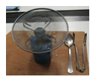
- Ask a child to hold out his hand and explain that he should not touch the spoon. Put the spoon near the child’s hand. Point out that the child can feel the heat although he can’t see the fire from the spoon.
- The spoon wasn’t the fire; the burner was the fire. The spoon absorbed some of the heat coming from the burner and then radiated some of it back.
- Something like this happens between the Sun and the Earth: rays of the Sun heat the Earth when they strike it, just like the spoon got heated by the burner, and just like the spoon radiates some of that heat back, the Earth also gives back some of its heat.
- Show chart 19a/MFE 13
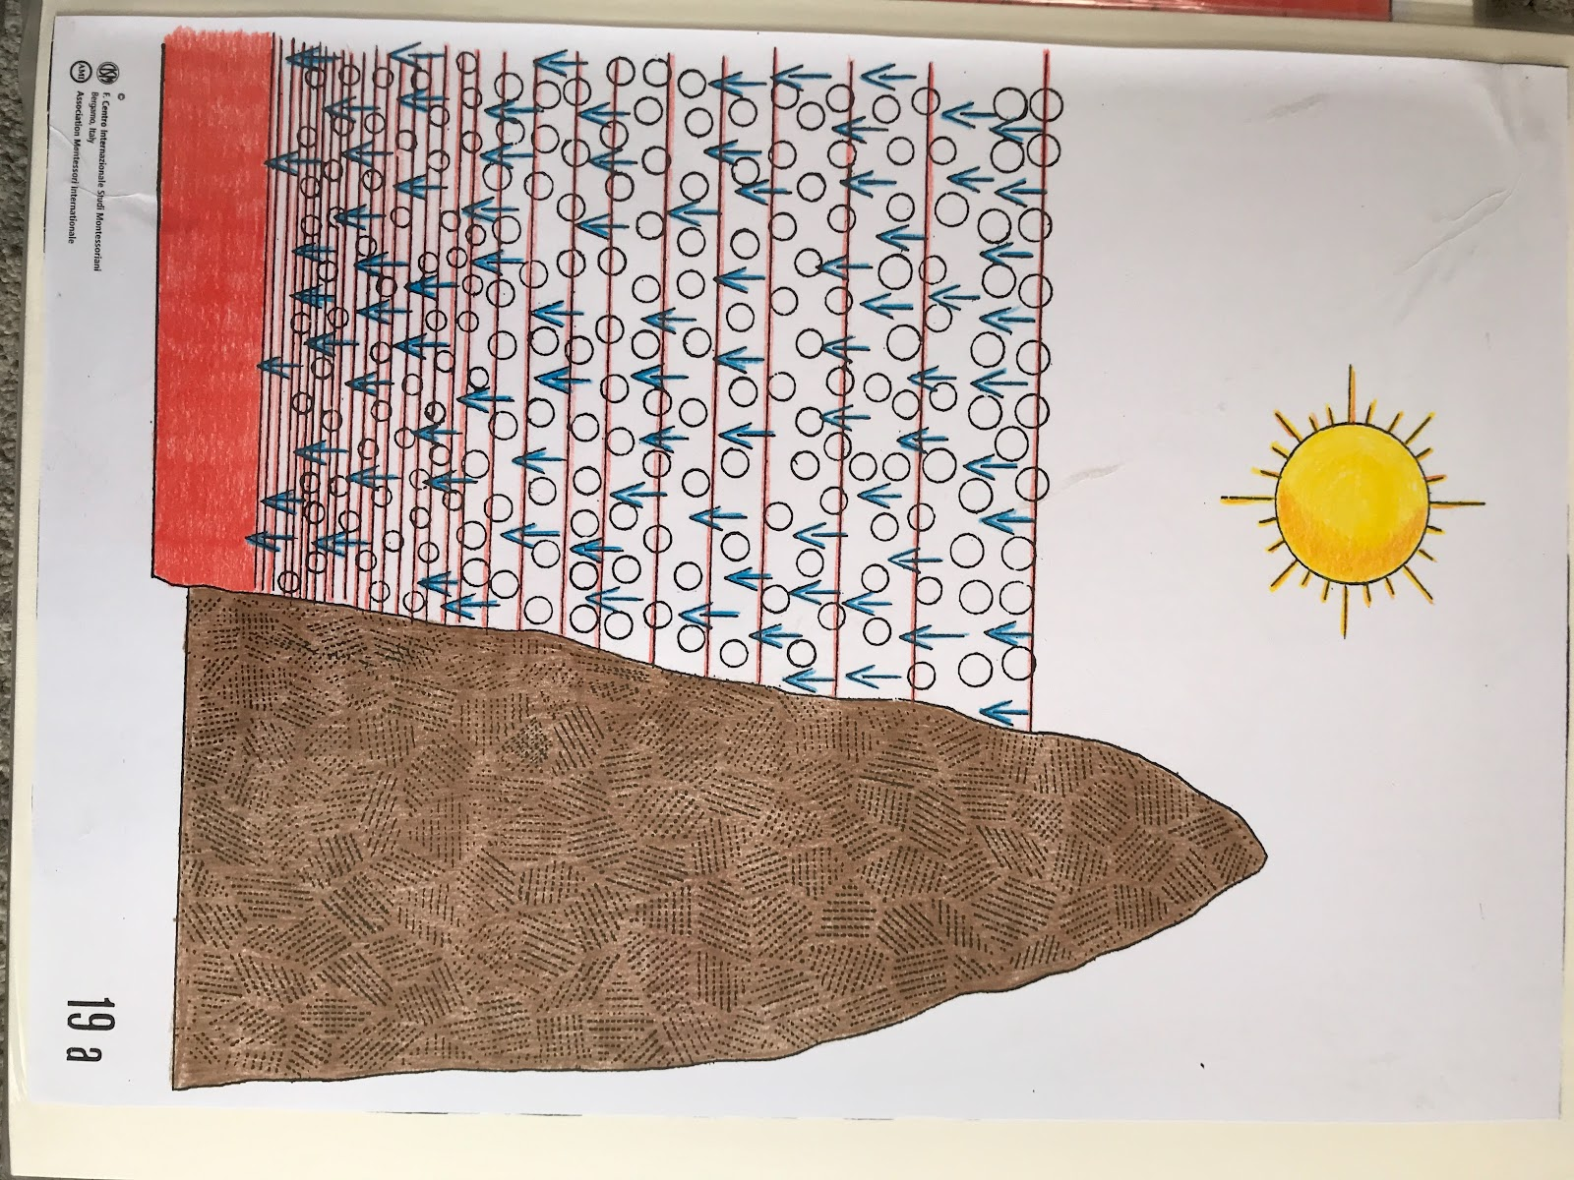
- The blue arrows represent the rays of the Sun, which are heating the Earth. Look at the red lines; towards the top we have a lot of space between them. They represent the layers of air. We can see how crowded these layers are closer to the surface of the Earth. The atmosphere is thinner at higher elevations and denser at sea level.
- The red part is at sea level, and represents the Earth retaining heat. Just like the spoon absorbed heat from the fire, the Earth absorbs heat coming from the rays of the Sun.
- Show chart 20a/MFE 14
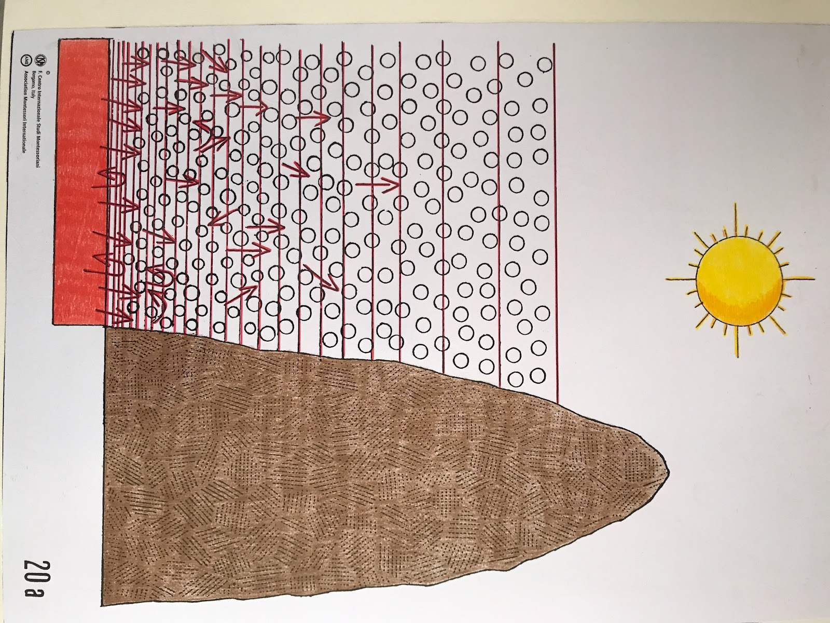
- Just as the spoon radiated some of that heat back, so the Earth radiates some of the heat back. Look at the red arrows: some go into the Earth and then turn and go back up to the atmosphere again.
- The atmosphere prevents some of the heat from escaping, like a blanket that holds heat in. Some of the arrows bend back into the Earth again, because the layers close to the Earth are very dense. Some of this heated air cannot make it through the dense layers.
- The heat does not get retained in the thinner atmosphere at high altitudes. 85% of the heat on Earth is retained heat that is radiated back out.
- Show chart 21a/MFE 15
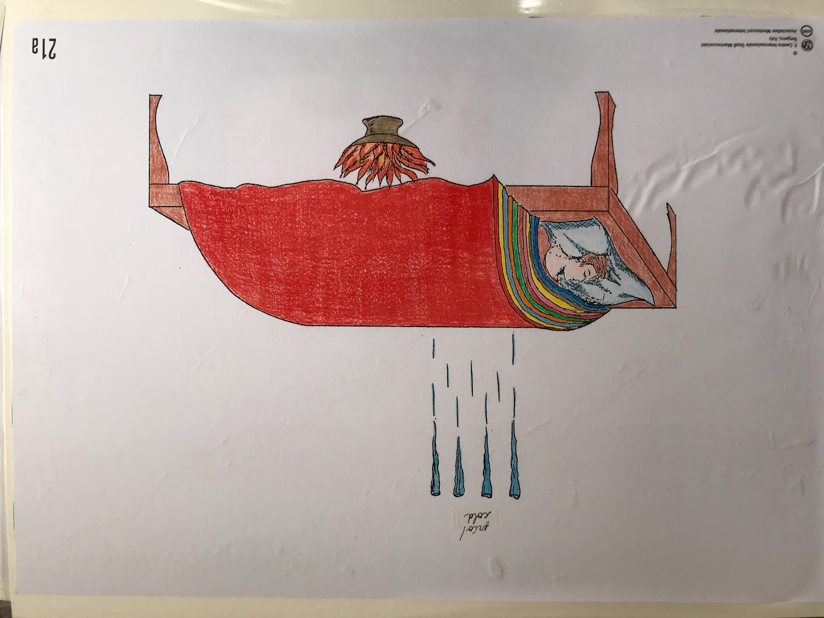
- The boy represents the planet Earth out in space. The cold represents the coldness of space. The retained heat that radiates out from the Earth and the protective blankets of the atmosphere help to keep the Earth warm.
- This chart highlights the importance of our atmosphere.
- Show chart 22a/MFE 16
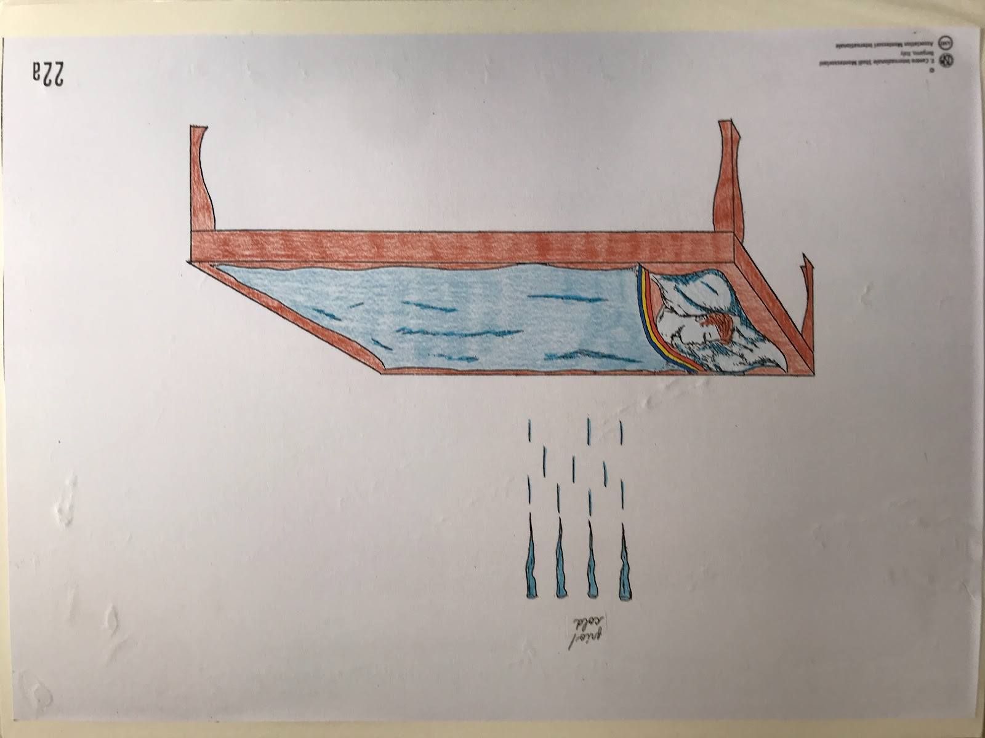
- This chart shows what the Earth would be like if there were no atmosphere and no radiated heat coming back out from the Earth. Because the boy does not have blankets and because there is no heat keeping him warm, he is very cold and very blue.

